Snapdeal- India’s largest online shopping marketplace,

35 million plus products

across 800 plus diverse categories

125,000 regional, national, and international brands and retailers.

With 30 millions of users and more than 500,000 sellers,

delivering to 6000+ cities and towns. More than 70 million users visit Snapdeal every month.

FLIPKART:

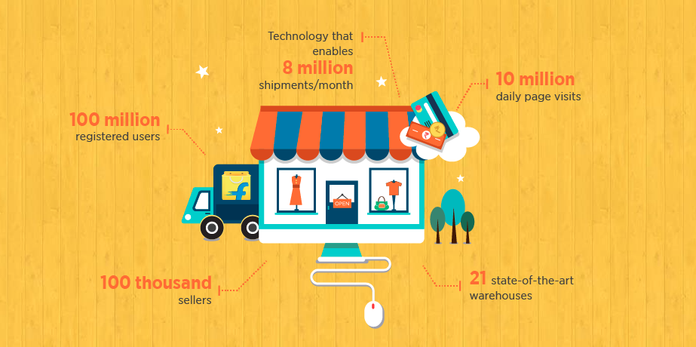

2020- Snapdeal opened 15 new warehousing centers at industrial hubs located across ten metro cities Ahmedabad, Surat, Jaipur, Indore, Hyderabad, Panipat, Gurugram, Mumbai, Bengaluru, and New Delhi. With the new addition, the company now runs 23 logistics centers. Snapdeal's logistics hubs offer dedicated facilities for manufacturing units, including packaging of orders and online tracking for orders in transit, and facilitate faster movement of packets.

In the past one year, Snapdeal has also added 1.3 million square feet of warehousing space spread over 25 cities, said Chitravanshi.

Flipkart- The ecommerce giant now has 15 fulfillment centers(35 warehouses) across the country amounting to a storage capacity of 2.5 million square feet.

The six new centres are owned by Snapdeal subsidiary Vulcan Express.Three of the facilities are located in the National Capital Region, with the others located in Lucknow, Hyderabad and Kolkata

Snapdeal has partnered with several global marquee investors and individuals such as SoftBank, BlackRock, Temasek, Foxconn, Alibaba, eBay Inc., Premji Invest, Intel Capital, Bessemer Venture Partners, Mr. Ratan Tata, among others.

[Snapdeal](https://www.crunchbase.com/organization/snapdeal) [$1.8B](https://www.crunchbase.com/search/funding_rounds/field/organizations/funding_total/snapdeal) in funding..[Snapdeal](https://www.crunchbase.com/organization/snapdeal) has had [5](https://www.crunchbase.com/search/organizations/field/organizations/num_exits/snapdeal) exits.[Snapdeal](https://www.crunchbase.com/organization/snapdeal)'s most notable exits include [FreeCharge](https://www.crunchbase.com/organization/freecharge), [Vulcan Express](https://www.crunchbase.com/organization/vulcan-express), and [NuvoEx](https://www.crunchbase.com/organization/nuvo-ex),gojavas.[Snapdeal](https://www.crunchbase.com/organization/snapdeal) has acquired [12](https://www.crunchbase.com/search/acquisitions/field/organizations/num_acquisitions/snapdeal) organizations. Their most recent acquisition was [GoJavas](https://www.crunchbase.com/organization/gojavas) on Jul 14, 2016.

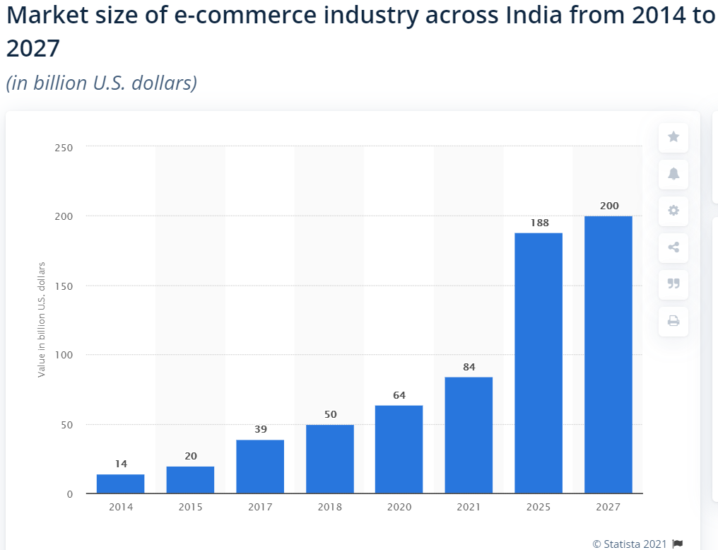

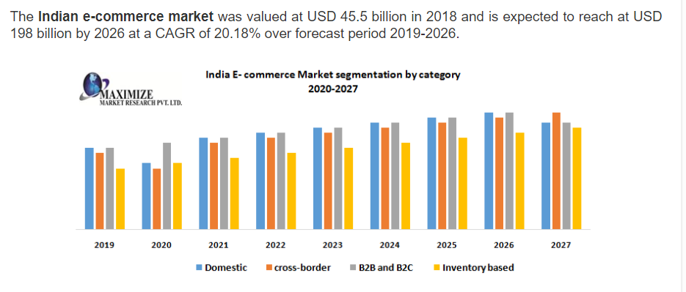

Market growth and size-The growth in E-commerce sector will also boost employment, increase revenues from export, increase tax collection by ex-chequers, and provide better products and services to customers in the long-term. Rise in smartphone usage is expected to rise 84% to reach 859 million by 2022.E-retail market is expected to continue its strong growth - it registered a CAGR of over 35% to reach Rs. 1.8 trillion (US$ 25.75 billion) in FY20. Over the next five years, the Indian e-retail industry is projected to exceed ~300-350 million shoppers, propelling the online Gross Merchandise Value (GMV) to US$ 100-120 billion by 2025. In 2018, the [e-commerce sales across India](https://www.statista.com/statistics/261336/b2c-e-commerce-sales-growth-in-india/) were estimated to increase by 25 percent. The growth rate, however, was predicted to observe a slight dip in 2022. Consequently, the revenue-generating potential has also increased. The [average retail e-commerce revenue collected per user in India](https://www.statista.com/forecasts/226160/e-commerce-arpu-in-india) in 2018 was more than 50 U.S dollars. It was estimated to cross 75 U.S dollars by 2024.

**Snapdeal revenue rises marginally to Rs 846 crore in FY20.net loss shrinking to Rs188 crore from a staggering Rs5,143 crore in 2017.**During the year under review, Snapdeal saw more people coming to its platform to shop, with the number growing from 19 million in FY19 to 27 million buyers in FY20.[Snapdeal](https://www.financialexpress.com/tag/snapdeal/)’s net losses increased by a little over 43% year-on-year at Rs 270.2 crore in the year to March 31, 2020, the company’s filings with the RoC sourced from business intelligence platform Tofler showed.[Snapdeal](https://www.financialexpress.com/industry/sme/snapdeal-losses-jump-47-in-fy20-revenue-drops-1-amid-covid-led-sales-disruption-in-q4/2156939/) said more than 27 million annual buyers and over 380,000 registered sellers transact on its platform. The company claims to have hosted more than 70 million unique monthly visitors during FY19-20. “With continuing focus on improving user experience, we have seen an increase in visitors and improved conversion rate as against last year. Our operating revenue for FY19-20 is at par compared to last year even with the early impact of Covid-19 pandemic-related lockdowns,” the company said in the filings.

Competitors [Amazon](https://www.financialexpress.com/tag/amazon/) and [Flipkart](https://www.financialexpress.com/tag/flipkart/) that lead the e-commerce market also reported an increase in losses. However, they recorded higher growth in revenue too. Amazon and Flipkart’s revenue from operations rose by nearly 43% and 40% to Rs 1,0847.6 crore and Rs 5,916.3 crore respectively. For Amazon, losses increased only marginally while Flipkart posted a 19.21% rise in net losses.

Even as expenses rose to Rs 1,168.3 crore in FY20 from Rs 1,087.6 crore in FY19, revenue from operations remained stagnant at Rs 813.9 crore during the year.

Snapdeal inventory management- To make sure its sellers are not left out on a limb, [Snapdeal](https://indianonlineseller.com/category/news-and-updates/marketplace-watch/snapdeal/) has simplified the way you manage your Snapdeal (SD) Plus inventory. The marketplace now offers informative SD plus inventory reports and SUPC-based stock transfer reports. Sellers can access these directly through the seller panel. Sellers were made aware of the same through email.

|  |  |  |
| --- | --- | --- |
|  | **Snapdeal** | **Flipkart** |
| Founded | 2010 | 2007 |
| Founders | Kunal Bahl and Rohit Bansal | Sachin Bansal and Binny Bansal |
| Location | Delhi, India | Bangalore, India |
| Pivot | Changed to a marketplace model in 2011 | Changed to a marketplace model in 2012 |
| Current Model | * Pure-play marketplace, where snapdeal only hosts traders * Does not handle its own logistics, teams up with other logistics company * Has its own payment solution, KlickPay. But, it is focused on its marketplace platform | * Follows a hybrid model where it also sells its own products while having traders no its website * Runs its own logistics service, eKart * Intends to be more than just an ecommerce company |
| Market Strategy | * Company focuses on middle income market * Expand to almost all categories, focusing on unique unbranded products * Increasing focus on mobile | * Company targets every Indian who shops online * Intends to offer everything except automobiles * Increasing focus on mobile |
| Revenue | INR 916 Cr | 346.1 billion Indian rupees |
| Warehouse areas | 1.3 million square feet | 2.5 million square feet. |
| Logistics | Snapdeal ran on a purely seller-focused model. This means that sellers are completely responsible for providing the goods. Snapdeal merely facilitates the payment and (in some cases) the delivery logistics. | 1. eKart is what was earlier known as Flipkart Logistics.eKart is part of WS Retail Services Private Limited, the business-to-customer company of Flipkart 2. It is more economical than other 3rd party logistics companies 3. Being able to service more orders through other ecommerce websites will allow eKart to scale and expand its network, which will in turn benefit Flipkart as well 4. eKart's reach - 150 Cities, the largest such network set up by an online retailer in India 5. eKart currently offers services such as delivery logistics, reverse logistics and pay on delivery |

Both Flipkart and Amazon have “Seller-fulfilled” products that the marketplace has no control over. If anything goes downhill (product delivery, quality, returns), you have to take it up directly with the seller.

However, Snapdeal relied on this model far too much. This may be fine if you’re primarily a low-cost goods marketplace like Shopclues, but when it comes to white goods and pricey stuff, buyers expect a minimum of marketplace quality control, as well as well-defined policies with regard to return windows, return conditions, etc.

Snapdeal didn’t have any of this until Flipkart was well ahead and Amazon was making inroads. It then moved to the SD+ model, where some goods would be kept in Snapdeal’s own warehouses. But even this failed to reinstate customer confidence.

Category differentiation - Both Amazon (the US version) and Flipkart started out as online bookstores, but if you go to either [http://Amazon.com/.in](http://amazon.com/.in) or [Online Shopping Site for Mobiles, Electronics, Furniture, Grocery, Lifestyle, Books & More. Exclusive Offers!](http://flipkart.com/), you’d note the mind boggling variety of categories. Look closely though, and you’d notice that each has its own specializations.

For instance, Flipkart (with Myntra) controls a much higher share of the fashion space among major e-tailers. On the other hand, Amazon offers a range of options on computer hardware that Flipkart doesn’t. So people seeking specific stuff know they’ll first go to x website and then y.

Sadly, Snapdeal doesn't figure as either x or y. It comes in a distant third z, which people would go to if they would find that x or y either didn’t have deals on offer, or the product was simply out of stock there. This isn’t a reputation that builds sales in the longer term.

Sellers already had big enough warehouses to cater to the orders which Snapdeal was giving us. And the stock in our warehouse could be sold on Flipkart and other sales avenues also.

Snapdeal’s logic to open their warehouses was to ensure on time and correct dispatch and fast delivery. And also to rake more funding against these warehouses from investors.

The Problem was, unlike Flipkart and Amazon, Snapdeal rolled out this service for free to sellers. Sellers were not keen to send stock over there due to various operational issues and were happy dispatching from their own warehouses. (Dropshipping)

This is where Snapdeal started having its downfall.

They made the first of the numerous changes in their system.

1. Snapdeal put a cap on the daily orders that a seller could dropship. So that sellers would be forced to use warehouses.This resulted the warehouses of one region were not big enough to accommodate all sellers. This led to products being shown as out of stock on Snapdeal.
2. Second change, now a new change was made, the Central team in Delhi would create an ASR (Advance Stock Receipt) of the goods that you could send to the warehouse, this would take upto 7 days to get generated. (In Amazon you yourself generate ASR). At the same time, goods were not showing in stock on Snapdeal.This used to be a big problem during peak season, and this would lead to stock being stranded at sellers warehouse, or stocks being inwarded post the season, which would lead to clogging of Snapdeal’s warehouse.
3. Third Change, as sellers has no option, they would have to send all goods to the warehouses, so even slow moving and newly introduced products were sent to the warehouses, this would clog the warehouses. So they started a new policy, only high moving products will be allowed in priority to the warehouse. Who decides high moving? Some “Algorithm”.Here I will give you an example, suppose the Algorithm was introduced in May, at that time, Ice Creams were high moving, and Sweaters were slow moving.So Algorithm likes ice cream, hates sweaters.So in Diwali, it wants ice cream in warehouse, and no sweater.Result, in demand goods were not available on Snapdeal, out of demand goods were jamming their warehouses.Consequently, the in demand goods were available to sell and buy on Flipkart and Amazon.By now Snapdeal had lost the plot and sellers were recalling inventory from warehouses so that they could be sold on other channels.
4. Fourth change, they refused the sellers to call back inventory from warehouses.Now, as there were no sales, sellers stopped sending inventory to Snapdeal warehouses and stopped concentrating at Snapdeal.I will give my example : I deal in trousers, Size 28 and 40 were available for sale as they were in Snapdeal warehouse, but balance sizes were not available as I did not want to send goods to their warehouse and Snapdeal did not want me to dropship. As a result, if Snapdeal would advertise my product, a customer would like the image and go in to order it, but could not find the size that would fit him. So customer would search same product on Flipkart and buy from me over there.

Value Proposition - Value for money (from a consumer perspective) is something the Indian wants above all else. This demands that marketplaces strike deals with individual brands. For instance, when Xiaomi came to India, it remained a Flipkart exclusive for a long time. All the flash sales went through Flipkart, which not only brought greater revenue, but increased consumer interest in the overall website. Similarly, OnePlus has shown a preference for Amazon.

Snapdeal again failed to produce meaningful partnerships to such brands. Hence, you could be sure that anyone hyped about a new smartphone brand would not go there, but would only look for existing players.

All of these problems naturally worsened Snapdeal’s fundamentals. From 2016 onwards, it failed to keep up the cash burn that Amazon and to a lesser extent, Flipkart, engaged in in order to retain the Indian customers. Funding began to dry up and valuation tumbled. Eventually, it entered talks with Flipkart for a merger. The talks failed last year, leading to Snapdeal’s top honchos heading out en masse.

[Snapdeal scripts a comeback nine months after merger talks fail](https://economictimes.indiatimes.com/small-biz/startups/newsbuzz/snapdeal-scripts-a-comeback-nine-months-after-merger-talks-fail/articleshow/64072073.cms)

[Snapdeal: Rise and fall of an Indian unicorn](https://www.livemint.com/Companies/8bzgpgNg8jeDM22YVydk5I/Snapdeal-Rise-and-fall-of-an-Indian-unicorn.html)

[Flipkart gets advantage of Snapdeal’s decline](https://www.financialexpress.com/industry/flipkart-gets-advantage-of-snapdeals-decline/1078188/)

<https://retail.economictimes.indiatimes.com/news/e-commerce/e-tailing/snapdeal-joins-international-trademark-association/72135331>

<https://www.forbesindia.com/article/take-one-big-story-of-the-day/how-snapdeal-is-turning-around-its-fortune/64189/1>

<https://www.financialexpress.com/industry/snapdeal-net-losses-increase-by-43/2169691/>